Nepal College of Information Technology
Unit Test
Fall 2013
Program : BE IT Time : 2 hrs
Semester : (III) FM : 70
Subject : Electronic Circuits & Instrument PM : 35

- Candidates are requested to give their answer as far as practicable in their own words.
- The figure in the margin indicates the full marks
- Attempt ALL question

1 a Describe the effect of shunt capacitance on low frequency response with necessary diagram. 7
b Find overall voltage gain (VL/Vs) in dB and show all its values in equivalent circuit of circuit below. ( Assume re= 25Ω , β = 100 , rc = 10 kΩ ) 8
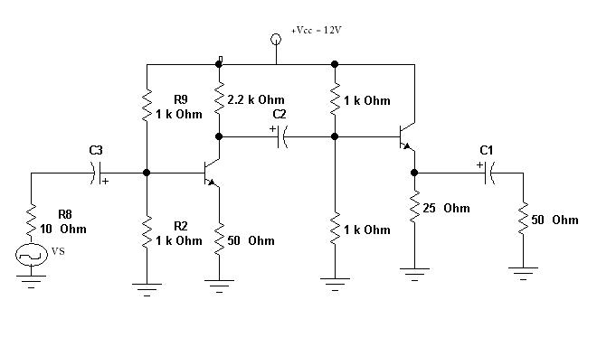

2 a. Describe Transformer coupled class B push-pull Amplifier in detail with neat waveform. 7
b. What is efficiency? Derive the efficiency of transformer coupled load Class A amplifier. Why is efficiency of transformer coupled Class A amplifier greater than that of series-fed class A amplifier? 1+5+2
3 a. Justify the statement “ Negative feedback improves SNR and makes gain stable” 8
b. Derive the overall input and output impedance of Voltage series Negative feedback connection. 7

4. a. Design a wein-bridge oscillator oscillating at a frequency of 25 KHz. 5
b. An amplifier gain changes by ± 10%. Using the negative feedback, the amplifier is said to be modified to yield a gain of 100 with ±0.1% variation. Find the required open loop gain of the amplifier and the amount of the negative feedback. 5
c. Explain Barkhausen Criteria for oscillation. Explain Push-Pull Amplifier. 2+3

5. Write short notes on: (Any Two) 5*2=10
a) Distortion in amplifier
b) Frequency Response of Amplifier
c) Cross Over Distortion

